Organic chemistry

Question Paper 2

|  |  |
| --- | --- |
| School | Miritini Secondary School |
| Student’s Name |  |
| Level | KCSE |
| Subject | Chemistry |
| Topic | Organic chemistry |

**Time allowed:** 1Hour 7 min

**Marks scored: ______/ 40**

1. Study the flow chart below and answer the questions that follow.

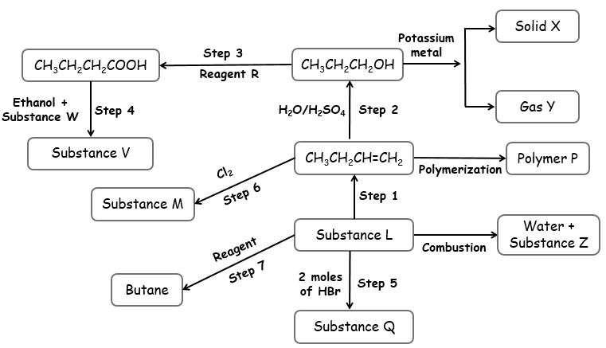

1. Draw the structural formula of;
2. Substance L [1]
3. Polymer P [1]
4. Name the following substances.
5. M _____________________________ [1]
6. Q _____________________________ [1]
7. V _____________________________ [1]
8. W _____________________________ [1]
9. Write an equation of reaction taking place in:
10. Step 4 [1]

________________________________________________________________

1. Production of substance Z [1]

________________________________________________________________

1. Production of solid X and gas Y. [1]

________________________________________________________________

1. Determine the number of moles of reagent required in **step 7**. [1]

________________________________________________________________

1. Name the conditions necessary for the reactions in step **1**, **2**, **3** and **4**.

Step 1 __________________________________________________ [1]

Step 2 __________________________________________________ [1]

Step 3 __________________________________________________ [1]

Step 4 __________________________________________________ [1]

1. Identity the processes taking place in steps **2, 3, 5** and **7.**

Step 2 __________________________________________________ [1]

Step 3 __________________________________________________ [1]

Step 5 __________________________________________________ [1]

Step 7 __________________________________________________ [1]

1. What class of organic compounds does substance V belong to? [1]

_______________________________________________________________

1. State one general characteristic of the class of compound that V belongs to. [1]

_______________________________________________________________

1. Describe how one can use a Bunsen flame to differentiate between butane and butane. [2]
2. The scheme below shows some reactions starting with propanol.

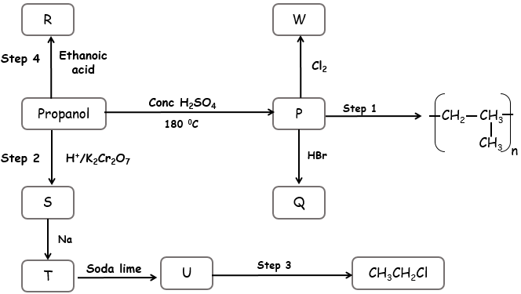

1. Name substances R, P, S and T.
2. R _____________________________ [1]
3. P _____________________________ [1]
4. S _____________________________ [1]
5. T _____________________________ [1]
6. Draw the structural formula of;
7. Substance W [1]
8. Substance U [1]
9. Name the reagent and condition represented in **step 3**.

Reagent _______________________________________ [1]

Condition ______________________________________ [1]

1. Name the type of reaction in;
2. Step 1 _________________________________ [1]
3. Step 4 _________________________________ [1]
4. Write the chemical equation in step 4. [1]

_______________________________________________________________

1. The scheme below shows some reactions of ethanol. Study it to answer the question that follow.

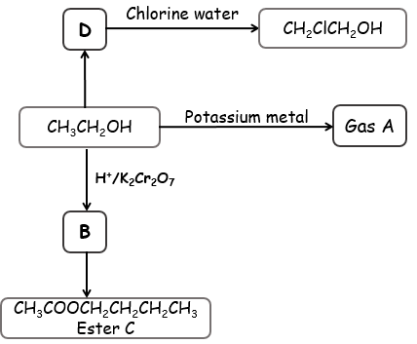

1. Name gas A. [1]

_____________________________________________________

1. Write and name the structural formulae of substances B and D.

Substance B [1]

Substance D [1]

1. Name the type of reaction that take place when D reacts with chlorine water. [1]

____________________________________________________________

1. Name the reagent and condition necessary for **B** to react and form **Ester C**.

Reagent [1]

______________________________________________________

Conditions [2]

______________________________________________________

______________________________________________________